Radial nerve
- The radial nerve is the largest branch of the brachial plexus
- Most frequently injured branch of both the posterior cord as well as the brachial plexus

Root value
C5, 6, 7, 8 and T1

Formation
Originates as a terminal branch of the posterior cord of the brachial plexus
Posterior division of brachial plexus supplies extensors.
Posterior divisions of all trunks unite to form posterior cord.
Largest branch of posterior cord – radial nerve – supplies all the extensors

Course
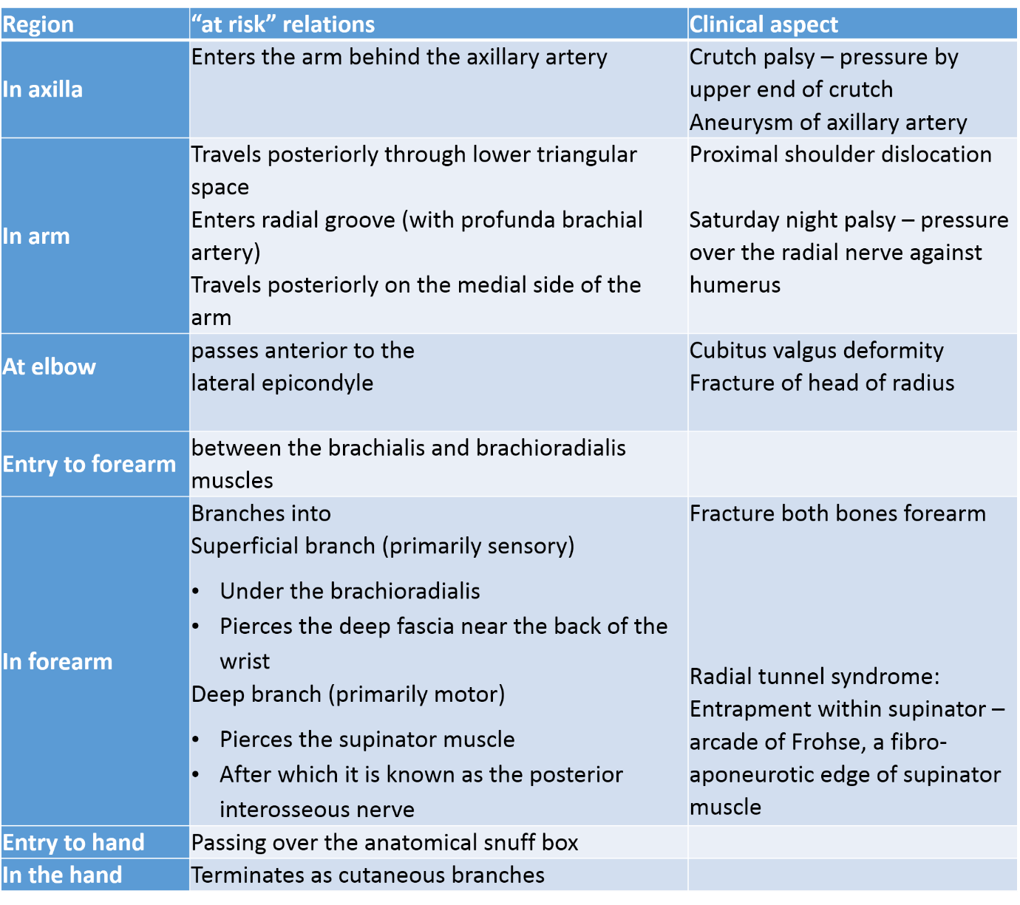
[TIP]Watch the video
[YOUTUBE]
Branches
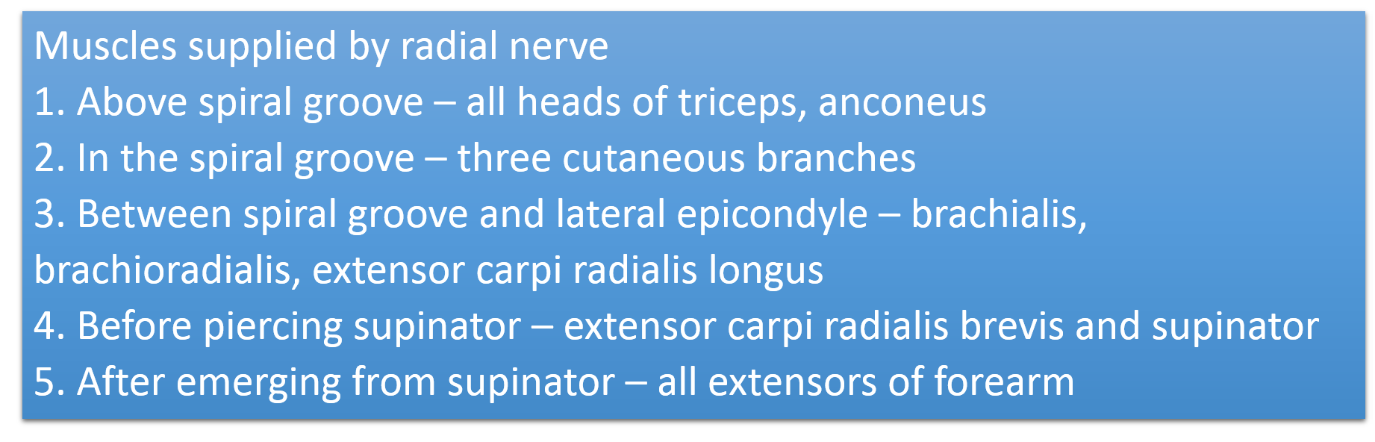
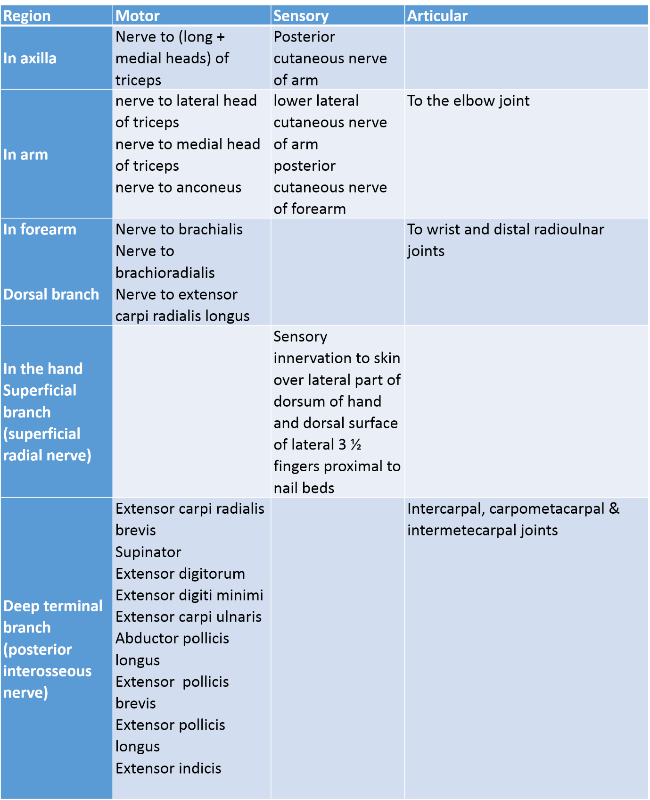
[TIP]Watch the video
[YOUTUBE]

Spiral groove
Boundaries:
- Anterior – shaft of humerus
- Posterior – long head of triceps
- Superior – origin of lateral head
- Inferior – origin of medial head
- Contents – radial nerve with branches + profunda brachii vessels

Radial nerve in spiral groove lies in direct contact with humerus

Radial nerve in spiral groove gives five branches
- Lower lateral cutaneous nerve of arm
- Posterior cutaneous nerve of forearm
- Nerve to lateral head of triceps
- Nerve to medial head of triceps
- Nerve to anconeus

Medial head of triceps is supplied by radial nerve before spiral groove. In case of injury to radial nerve at spiral groove, elbow extension is spared.

Branches from posterior interosseous nerve
[YOUTUBE]

Injuries to radial nerve in spiral groove – 5S
1. Shaft of humerus fracture
2. Saturday night palsy
3. Surgical positions – Trendelenburg position
4. Syringe palsy
5. Esmarch tourniquet palsy

Radial nerve injuries
- Most common peripheral nerve to be injured
- Most common site of injury is distal end of humerus
- Thumb extension test – Hitchhiker’s test is the screening test

[TIP]Most common peripheral nerve to be injured
[WARNING]Most common site of injury is distal end of humerus
[INFO]Thumb extension test – Hitchhiker’s test is the screening test

Cutaneous innervation of radial nerve in hand
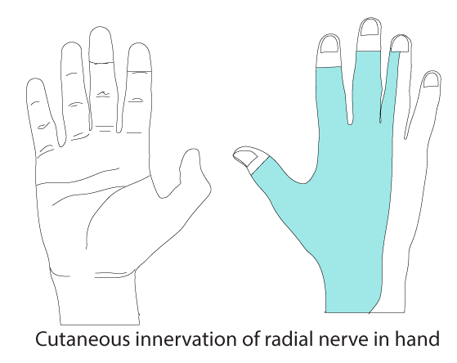
Autonomous zones of radial nerve
